Elephant Worksheet 3 Name: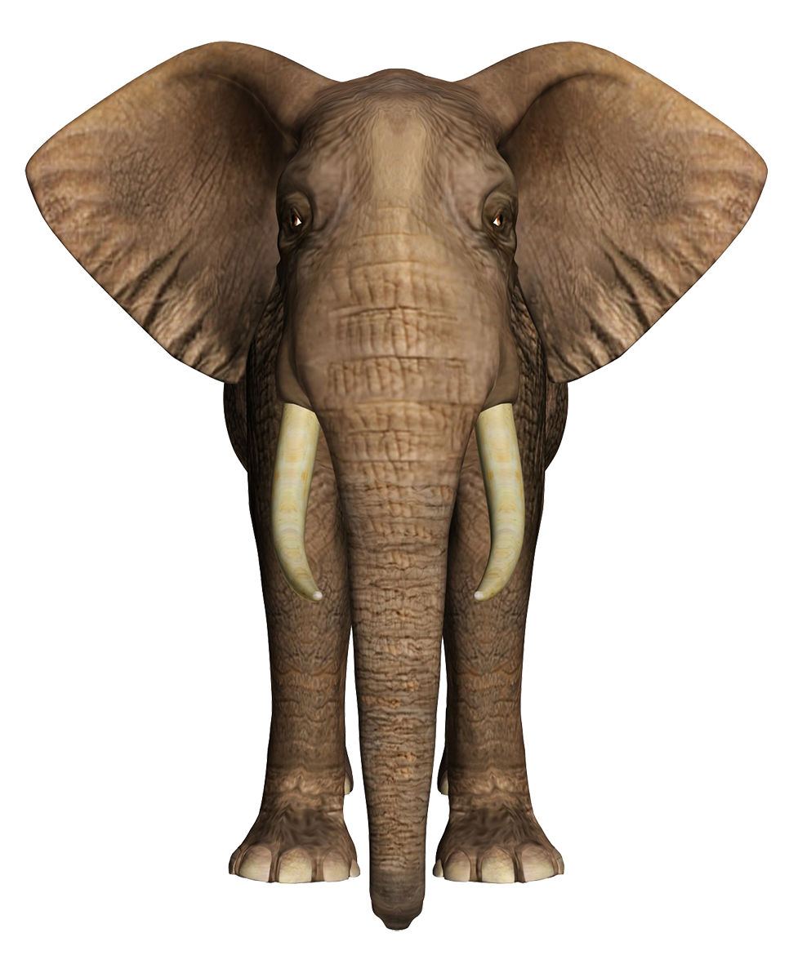

I can compare organism relationships



| Investigate: Gel electrophoresis  Gel 1  Count the bands on sample A, B and C in gel 1  Sample A=  Sample B=  Sample C=  The fragments that traveled the furthest are *smaller/larger*  *Gel 2 DNA Ladder Pop A Pop B Ivory Sample*  **Where in Africa Did the Tusks Come From?**  The tusks were shipped from a port in Tanzania. Did they come from elephants in that country, or were they transported there from other parts of Africa? You will use data from a reference map of genetic profiles of elephant populations that was built using DNA isolated from dung!  Using dung DNA to track poachers  Compare the ivory sample to pop A or pop B. Is the ivory sample more like population A or population B?  What’s your evidence?  *Source:CSI Wildlife Pop A Pop B Pop C Pop D*  The left lane shows a DNA ladder and lanes A–D show the alleles for Marker X present in each elephant population. Remember that each population profile consists of the alleles from several individual dung samples.  A researcher collected DNA from five dung samples in an elephant population. She amplified the sequence corresponding to the STR locus called "Marker X" and determined each allele's size using gel electrophoresis. The data are shown in the table. Samples that have an identical fragment for both alleles are homozygous for Marker X. If the alleles are different, the individual is heterozygous.   | **Dung Sample** | **Allele 1** | **Allele 2** | | --- | --- | --- | | 1 | 237 bp | 237 bp | | 2 | 252 bp | 245 bp | | 3 | 255 bp | 252 bp | | 4 | 252 bp | 252 bp | | 5 | 245 bp | 237 bp |   Which of the lanes shown at left corresponds to the Marker X profile for this population? |
| --- | --- | --- | --- | --- | --- | --- | --- | --- | --- | --- | --- | --- | --- | --- | --- | --- | --- | --- |

Elephants and Other Species

| Relationship | Description | Is this a +/+, +/-, +/0? | Species Example(s) |
| --- | --- | --- | --- |
| Mutualism |  |  |  |
| Commensalism |  |  |  |
| Parasitism |  |  |  |

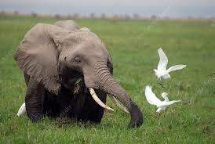

**Example 1:** Oxpeckers and cattle egrets are two species of birds that land on elephants and spend their days eating lice, ticks, and other parties out of the elephants' skin and hair. The elephants benefit by having dangerous critters removed from their bodies, and the oxpeckers get a snack and a free ride.

*What type of relationship? Fill into chart above*

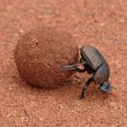

**Example 2:** The dung beetle retrieves its nourishment from the elephant’s dung, while on the other hand, the elephants are totally indifferent to what happens to its waste.

*What type of relationship? Fill into chart above*

**Example 3:** The elephant-specific intestinal fluke Protofasciola robusta, likely to be an ancestral species within the Fasciolidae (Lotfy et al., 2008), has been associated with intestinal tissue damage, hemorrhage and death in free-ranging African elephants (Vitovec et al., 1984; Obanda et al., 2011)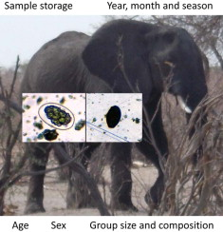

*What type of relationship? Fill into chart above*

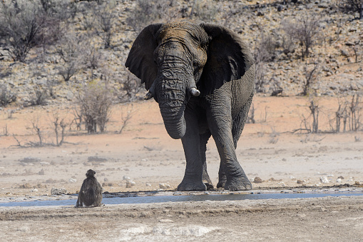

**Example 4:**In Eritrea, a country in the Horn of Africa, olive baboons and elephants have formed a symbiotic relationship. The baboons drink from water holes dug by the elephants, and the elephants rely on baboons sitting in the treetops to alert them to danger.

*What type of relationship? Fill into chart above*

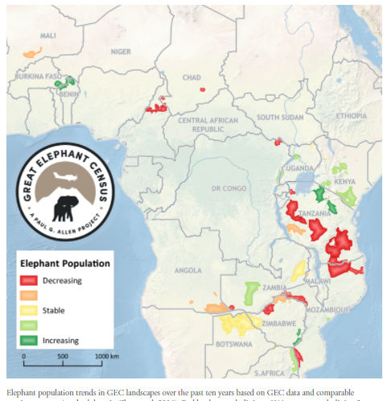

Look at the African continent, make observations on the elephant populations?

Pose a question about populations in different countries

What is the rate of growth in this population between 1950 and 1960?*Show me the math!!*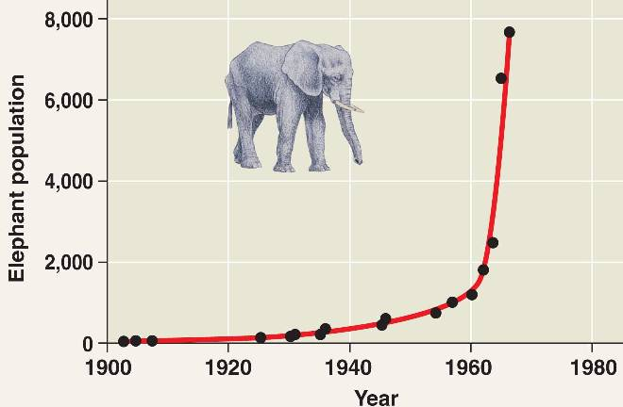

*Dy/dt*

Is this logistic or exponential growth?

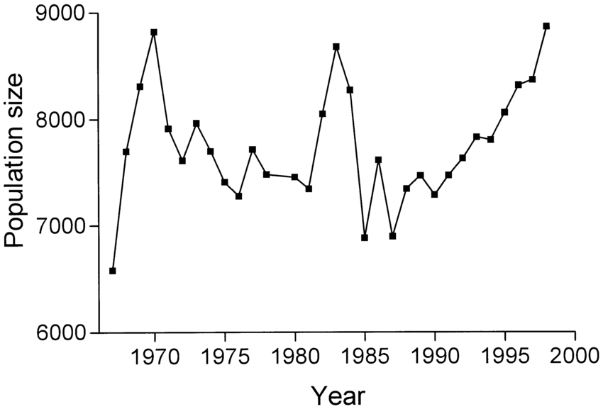

What is the rate of growth in this population between 1975 and 2000?*Show me the math!!*

*Dy/dt*

Is this logistic or exponential growth?

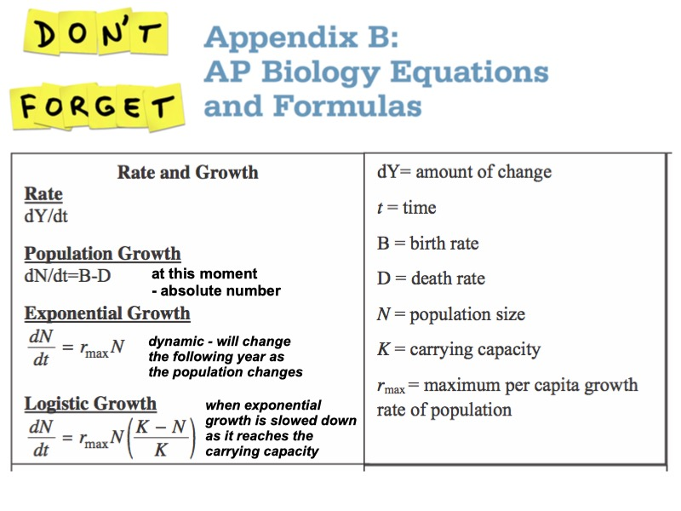

Calculate math and fill in on self grading worksheet. Show me the math!!

1. A pop of 23,473 elephants has 2,342 births and 473 deaths. What is the growth rate for this population?
2. One thousand two hundred and seventy deer are living on an island that is eight hundred and thirty square kilometers in size. What is the population density of the deer per square kilometer?
3. In 2002, 16.47 million babies were born in China. What was the birth rate (as a percentage and per 1000)?
4. *There are 252 elephants in a population. There is no net immigration or emigration. If 47 elephants die and 32 elephants are born in one month, what is the population size at the end of the month? Round to the nearest whole number.*
5. In a population of 600 squirrels, the per capita birth rate in a particular period is 0.06 and the per capita death rate is 0.12. What is the per capita growth rate of the population? Round to the nearest hundredth.
6. *If rmax = 1.0 and carrying capacity (K) = 1,500, calculate the population growth rate, where population size (N) = 1,600. What is happening to this population?*



| A lion kills and eats an elephant. Cellular respiration begins. Say steps out loud as you move your finger across screen (right/left brain).    How is ATP made in glycolysis, Krebs, and ETC?  How do elephants react to being chased?  Say steps out loud as you move your finger across screen (right/left brain)    What molecules amplify the signal? |
| --- |

Elephant population of South Africa

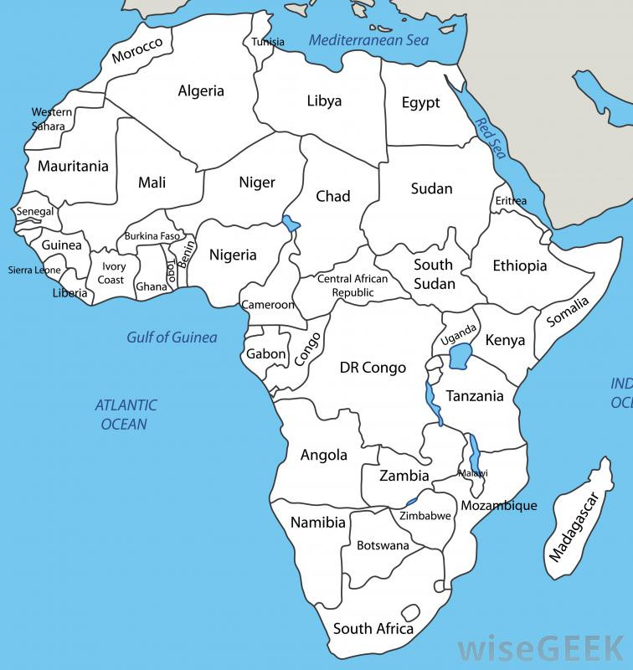

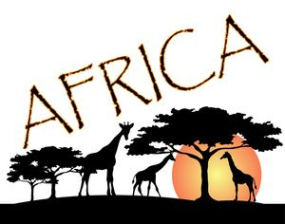





1. Color South Africa on map
2. Double Scan and read and describe

| Describe the elephant population of South Africa |
| --- |